# BrightSign Test Internet Connectivity Issue

## Situation

When Internet connectivity is down (ethernet cable is unplugged on wall jack), line to internet on diagnostics screen turns red.

## Expected Behavior

Line is supposed to remain red until the ethernet cable is plugged back into the wall. After internet connection is re-established, the line turns green.

## Actual Behavior

Some time after the internet loses connectivity, the line falsely turns green. Meaning the diagnostics screen is reporting a successful connection even though the internet is still down.

## Steps to Recreate

1. Put the following files on a blank MicroSD card
   1. autorun.brs
   2. classNetwork.js
   3. index.html
2. In classNetwork.js, insert the following code between lines 40 and 41

console.log(data);

1. The result should look like this

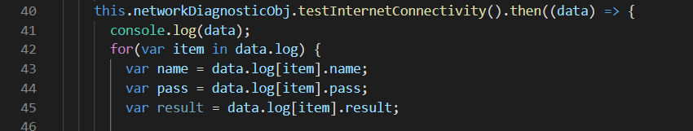

1. Save classNetwork.js, eject the MicroSD card and reset the BrightSign with the MicroSD loaded.
2. The display will show the current status of the Network and Internet. Both should be set to true.
3. 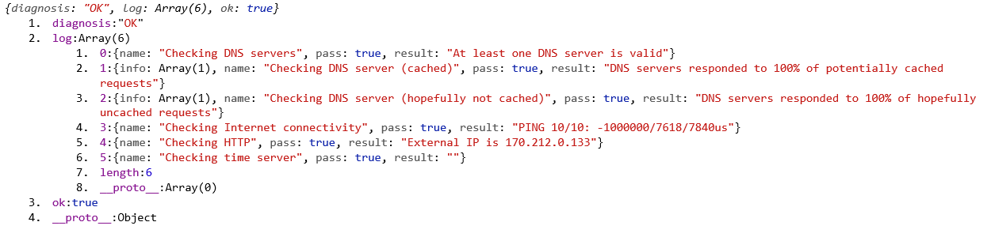Load the console on your computer. The console will begin to populate with “diagnosis OK” statuses as seen below.
4. 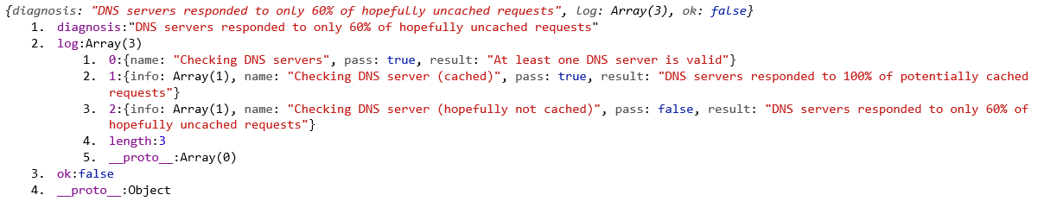Disconnect the internet. You will now see the following statuses.
5. 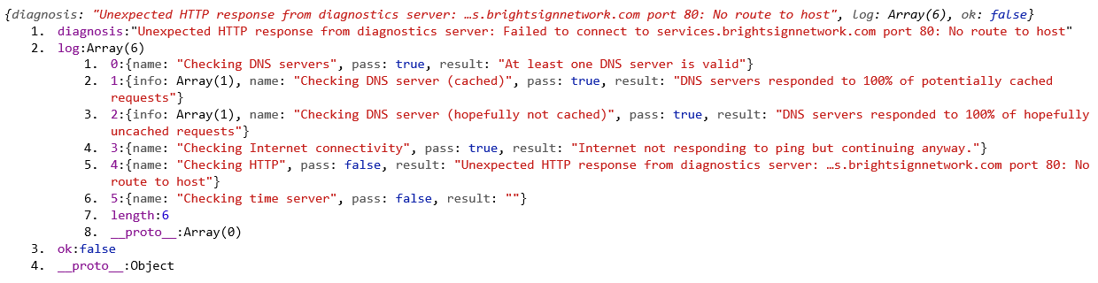After sometime, the hopefully not cached DNS server check comes back with true, which in turn updates the internet connectivity with true. This event will then show an “Internet | true” status on the large display. The problem is, there is no internet. Randall discussed with me the fickle behavior of the hopefully not cached DNS server check. It goes from true to false often. The following status is shown when this event occurs.

## Our Conclusion

We think the issue lies in the hopefully not cached DNS server check.

## Data Object Description

The data object contains three items:

1. “diagnosis” A diagnosis status
2. “log” The log, which contains all checked items and status updates
3. “ok” Whether or not all connections are true

On the log, we want to focus primarily on the item “Checking DNS server (hopefully not cached)”. This check pings the DNS server and waits for uncached responses. From above, you can see how the “pass” item in the check unreliably changes. The expected behavior is that the check stays consistent and accurately reflects the connection status of the DNS server.